Currently the bulk plant calculator is an excel sheet shared through the portal.

The personnel at the bulk plant, will take the call sheet and enter the data into the “Master Bulk Plant Calculator” to give a “Bulk Plant Loading” sheet. This sheet is then passed back and forth between the bulk plant and dispatch for their verification process.

Once verified, a printed copy is provided to the bulk plant to create the load. The split of the blends/loads is written on the printed load sheet and stored on a clipboard in the bulk plant. This information is then entered into AX as a product movement.

Using call sheet #1074548 for reference, the following information is captured:

Figure 1. The Call Sheet

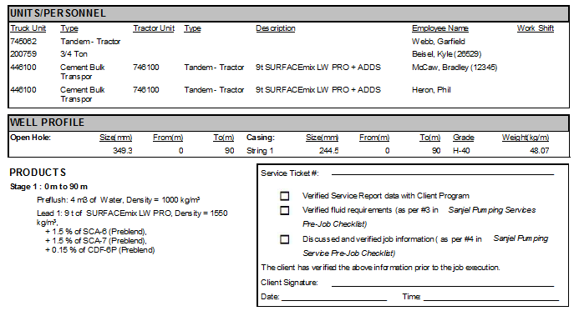

This data is entered into the calculator as follows:

Figure 2. Current Bulk Plant Calculator

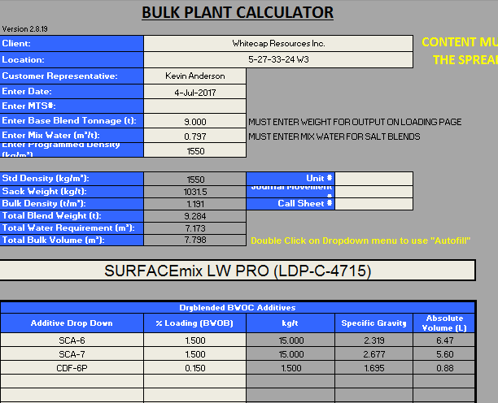

When satisfied with the entered data, click on the “Bulk Plant Loading” sheet:

Figure 3. Bulk Plant Loading Sheet

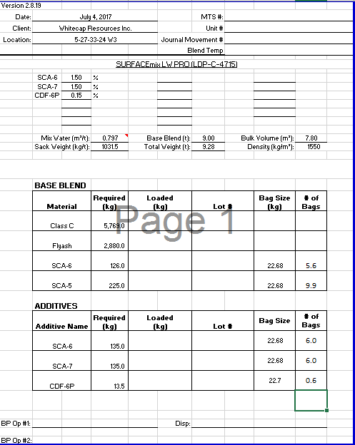

This will provide the recipe as to what to put into the required blend.

There are various challenges with this process:

* Manual input of data already entered into the call sheet
* Manual process to update information in the calculator
  + Cement blend recipes
  + Additives available
  + Additive properties
  + Blend and Additive Incompatibilities
  + Name updates
  + Max and Minimum density allowances – to flag blend when a density it out of spec.

To create a calculator within the system the following requirements are required:

* Manage cement blend recipes within the system allowing the laboratory to update, modify and create as required
* Manage additive properties within the system allowing the laboratory to update, modify and create as required
* Determine whether a recalculation of Mix Water, Yield, and density should be done for confirmation purposes

This process will also need the following:

* Use eService call sheet blends and additives in calculation
  + Manual entry of tonnage required
* Calculate recipes / load sheets based on “Base Blend” tonnage or “Blended Cement” tonnage
* Split Cement blend into loads
* Allow loads to have multiple cement blends
* Track loads
  + Knowing loads may occur before or after a call sheet is created
* Track remaining/surplus cement blends
  + Flagging of jobs not having enough cement
  + Knowing loads may occur before or after a call sheet is created
* Track units hauling cement to location or bulk facilities
* Track drivers hauling cement to location or bulk facilities
* Look at how AX product movements can be completed

The calculations for the loading sheet (Base Blend Calculation Method) are as follows:

The starting tonnage of 9 tonne, is indicated in the call sheet or Figure 1.

The recipe of SURFACEmix LW PRO (LDP-C-4715) is as follows:

Table 1. Blend Recipe

|  |  |  |  |  |  |  |  |  |  |
| --- | --- | --- | --- | --- | --- | --- | --- | --- | --- |
| Blend | Class C Amount | Flyash Amount | SCA-6 Amount | SCA-5 Amount | Mix Water | Yield | Density | Thixo? | AER Code |
| SURFACEmix LW PRO | 641 | 320 | 14 | 25 | 0.759 | 1.135 | 1550 | Y | 31 |

To get the following information for the base blend:

Table 2. Blend Breakdown

|  |  |  |  |  |  |
| --- | --- | --- | --- | --- | --- |
| **Material** | **Required (kg)** | **Loaded (kg)** | **Lot #** | **Bag Size (kg)** | **# of Bags** |
| Class C | 5,769.0 |  |  |  |  |
| Flyash | 2,880.0 |  |  |  |  |
| SCA-6 | 126.0 |  |  | 22.68 | 5.6 |
| SCA-5 | 225.0 |  |  | 22.68 | 9.9 |

$$Class C cement= Class C Amount x Base Blend Tonnage$$

$$Class C Cement=641 \frac{kg}{t} x 9t=5769 kg$$

$$Flyash=Flyash Amount x Base Blend Tonnage$$

$$Flyash=320\frac{kg}{t}x 9t=2880 kg$$

$$SCA-6=SCA-6 Amount x Base Blend Tonnage$$

$$SCA-6=14\frac{kg}{t}x 9t=126 kg$$

$$SCA-5=SCA-5 Amount x Base Blend Tonnage$$

$$SCA-5=25\frac{kg}{t}x 9t=225 kg$$

To get the following information for the Additives:

Table 3. Additive Requirements

|  |  |  |  |  |  |
| --- | --- | --- | --- | --- | --- |
| **Additive Name** | **Required (kg)** | **Loaded (kg)** | **Lot #** | **Bag Size** | **# of Bags** |
| SCA-6 | 135.0 |  |  | 22.68 | 6.0 |
| SCA-7 | 135.0 |  |  | 22.68 | 6.0 |
| CDF-6P | 13.5 |  |  | 22.7 | 0.6 |

$$SCA-6=SCA-6 \% x Base Blend Tonnage$$

$$SCA-6=1.5\% x 9t=0.135 t=135 kg$$

$$SCA-7=SCA-7 \% x Base Blend Tonnage$$

$$SCA-7=1.5\% x 9t=0.135 t=135 kg$$

$$CDF-6P=CDF-6P \% x Base Blend Tonnage$$

$$CDF-6P=0.15\% x 9t=0.00135 t=13.5 kg$$

The total Weight in the “Bulk Plant Loading” sheet, 9.28 t, is equal to the base blend tonnage + the additive mass.

* 9t (9000 kg) + 135 kg + 135 kg + 13.5 kg = 9283.5 kg = 9.28 t

Now if the calculation is done through entering the Blended Cement Calculation Method, the calculations will need to be slightly changed:

If 9.28 t is entered as the total blend weight required the following will need to be the calculations:

$$9.28 t=Base Blend Tonnage+Additive 1 tonnage+…………$$

Using the above example:

$$9.28 t=Base Blend Tonnage+1.5\% Add1+1.5\% Add2+0.15\% Add3$$

If we call Base Blend Tonnage “X” and know that the % additive is based on the base blend tonnage we get the following:

$$9.28 t=X+1.5\% X+1.5\% X+0.15\% X=X+3.15\% X$$

$$9.28 t=X+0.0315X=1.0315 X$$

$$\frac{9.28 t}{1.0315}=X=8.9966 t$$

Now that the base blend is calculated, use the same Base Blend Calculation Method as above.

$$Class C cement= Class C Amount x Base Blend Tonnage$$

$$Class C Cement=641 \frac{kg}{t} x 8.9966 t=5766.8 kg$$

$$Flyash=Flyash Amount x Base Blend Tonnage$$

$$Flyash=320\frac{kg}{t}x 8.9966 t=2878.9 kg$$

$$SCA-6=SCA-6 Amount x Base Blend Tonnage$$

$$SCA-6=14\frac{kg}{t}x 8.9966 t=125.95 kg$$

$$SCA-5=SCA-5 Amount x Base Blend Tonnage$$

$$SCA-5=25\frac{kg}{t}x 8.9966 t=224.9 kg$$

$$SCA-6=SCA-6 \% x Base Blend Tonnage$$

$$SCA-6=1.5\% x 8.9966 t=0.1349 t=134.9 kg$$

$$SCA-7=SCA-7 \% x Base Blend Tonnage$$

$$SCA-7=1.5\% x 8.9966 t=0.1349 t=134.9 kg$$

$$CDF-6P=CDF-6P \% x Base Blend Tonnage$$

$$CDF-6P=0.15\% x 8.9966 t=0.001349 t=13.49 kg$$

Now all of the above additives are added as a % of base blend. There are additives that are added as:

* % (BWOW)

Two current examples of this are NaCl and KCl.

So if the exact same example as above is used, but 3% KCl is added as an additive:

Figure 4. Additive entry in current bulk plant calculator with KCl

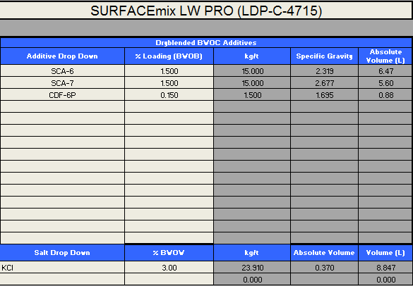

The Bulk Plant Loading” sheet changes to the following:

Figure 5. Bulk Plant Loading Sheet with KCl

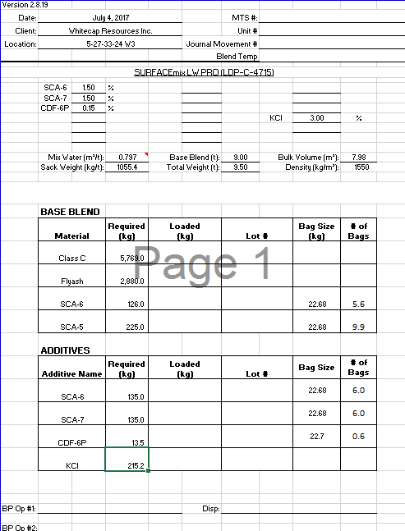

For all the base blend and additives (other than KCl), the calculations are the same as detailed above.

For KCl, the calculation changes since it is not added as a % of the base blend but as a % (BWOW)

$$KCl=KCl \% x Mix Water Requirement x Base Blend Tonnage$$

$$KCl=3.0\%\left(BWOW\right)x 0.797\frac{m^{3}}{t} x 9 t=0.21519 t=215.19 kg$$

Now if the Total blend weight is entered, instead of the base blend tonnage, the following calculation is required:

$$9.5t=X+1.5\% X+1.5\% X+0.15\% X+\left(3.0\% x Mix Water\right)X$$

$$9.5t=X+1.5\% X+1.5\% X+0.15\% X+\left(3.0\% x 0.797\right)X$$

$$9.5t=X+1.5\% X+1.5\% X+0.15\% X+\left(2.391\%\right)X$$

$$9.5t=X+5.541\% X=1.05541X$$

$$\frac{9.5 t}{1.05541}=X=9.0012 t$$

**Kg/m3 and l/m3 calculations:**

To determine the quantities of the items with UOM of kg/m3 and l/m3, the total base tonnage must be converted to volume then multiplied by the concentration.

To do this the cement yield must be known.

So for the above blend:

* Mix Water Requirement: 0.797 m3/t
* Yield: 1.18 m3/t
* Density: 1550 kg/m3
* Tonnage: 25 tonne

So for the following blend:

SURFACEmix LW PRO + 1.5% SCA-6 + 1.5% SCA-7 + 0.15% CDF-6P + 2.5 kg/m3 LCF-7

We want to calculate the quantity of LCF-7 required for the job.

$$LCF-7 Quantity=Base Blend Tonnage x Yield x Concentration$$

$$LCF-7 Quantity=25 t x 1.18\frac{m3}{t}x 2.5\frac{kg}{m3}$$

$$LCF-7 Quantity=73.75 kg$$

The calculation for l/m3 is the same as above except that the resulting quantity UOM is litre and not kg.

Visweep DM IS Calcuation

So for the above blend:

* Mix Water Requirement: 1.73 m3/t
* Yield: 1.34 m3/t
* Density: 1350 kg/m3
* Volume: 1 m3

So as following blend:

Visweep DM IS + 530.5kg/m3 Bulk Ground Silica + 6kg/m3 WG-6P + 5kg/m3 SA-2P + 20kg/m3 WWS-7P + 10kg/m3 MT-2 +6kg/m3 DF-6P